CHAPTER TWO

2.1 Introduction
This chapter presents a review of existing systems related to digital document management and cloud storage. The purpose is to analyze how these systems operate, their main features, as well as their strengths and limitations. This evaluation helps in identifying existing gaps and supports the justification for developing a new system.
In the modern digital era, many institutions rely on cloud-based platforms to store and manage documents. These platforms enable users to upload, access, and share files from different locations through the internet. They also offer functionalities such as security, backup, and file processing. However, most of these systems are designed for general use or developer-oriented applications and are not specifically tailored for academic tasks like examination script management.
This study reviews three systems: Uploadcare, Filestack, and OpenKM Document Management System. These systems were chosen because they represent different methods of handling files and documents, including developer-centered file services and enterprise-level document management solutions.
Each system will be examined based on its structure, features, advantages, and limitations. This analysis will help identify the shortcomings of current systems, particularly in managing examination scripts within educational institutions.
The outcome of this review will provide a basis for designing a more effective cloud-based examination script management system that addresses academic requirements.

2.2 Review of System 1: Uploadcare

2.2.1. Description of the System

2.2.1.1. Overview of the System
Uploadcare is a cloud-based file handling service developed for web and mobile applications. It enables users and developers to upload, store, process, and deliver different types of files, including images, PDFs, and videos. The system ensures fast file delivery through a content delivery network (CDN) and supports features such as file transformation, security, and storage management. Unlike traditional cloud storage platforms, Uploadcare is API-based and designed for easy integration into custom-built applications.

2.2.1.2. Context Diagram for Uploadcare

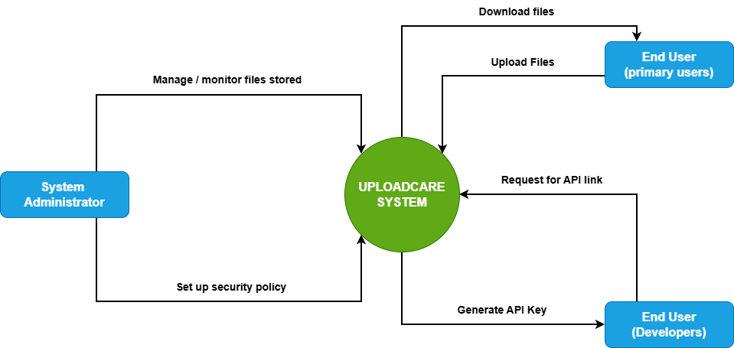
Figure 2.1
The context diagram illustrates the interactions between Uploadcare and its external users. End users can upload files to the system and download files when needed. Developers interact with the system by requesting API links, and the system generates API keys to allow secure integration with applications. System administrators manage and monitor file storage, as well as configure security settings to ensure safe and reliable file handling. The system communicates with all users through the internet and provides fast file delivery via its cloud infrastructure.

2.2.1.3. Use Case Diagram for Uploadcare

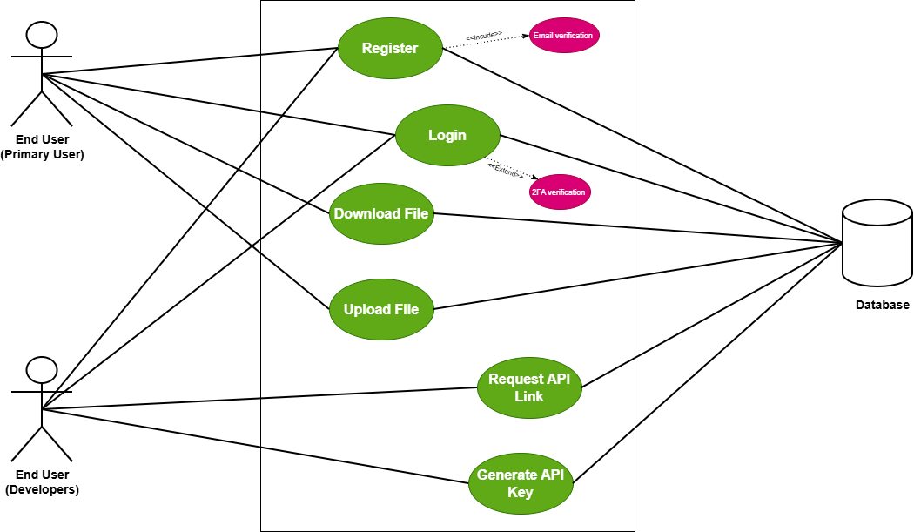
Figure 2.2

The use case diagram for Uploadcare shows how different users interact with the system. End users can register, log in, upload files, and download files, with registration including login verification and login supporting two-factor authentication for security. Developers can register, log in, request API links, and generate API keys to integrate Uploadcare into their applications. All these actions registration, login, file upload/download, API requests, and key generation are connected to the system database, which stores user credentials, file information, and API data. This ensures secure, organized, and manageable interactions between the users and the Uploadcare cloud service.

2.2.1.4. Sequence Diagram for Uploadcare

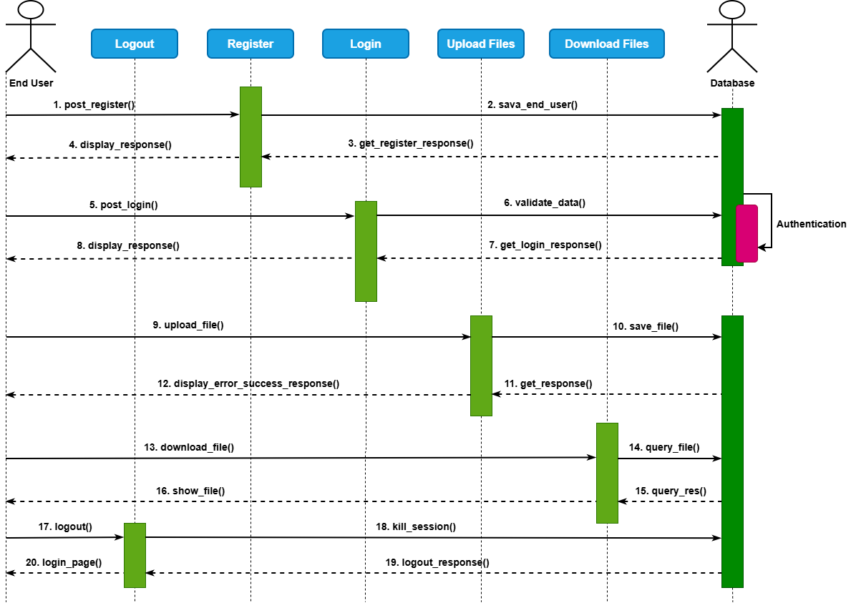
Figure 2.3

The sequence diagram illustrates the step-by-step interaction between a user and the Uploadcare system. First, the user registers, and the system saves the registration information in the database before returning a response to the user confirming success or failure. Next, the user logs in; the system validates the login data, authenticates the information against the database, and sends back a response indicating whether the login was successful. When the user uploads a file, the system stores the file in the database and returns a confirmation or error message. For file requests, the system queries the database and returns the retrieved files to the user. Finally, when the user logs out, the system terminates all active sessions and sends a logout confirmation response to the user. This sequence ensures secure, organized, and trackable user interactions with the Uploadcare system.

2.2.1.5. Features of the System
Uploadcare provides users with the ability to upload and store files, including images, videos, PDFs, and other large files. It supports automatic processing and optimization of images and videos to improve performance and reduce load times. The system ensures fast content delivery through its content delivery network (CDN) and provides secure access and authentication. Users can also upload files using a drag-and-drop interface or select files from multiple sources, while a developer-friendly API allows easy integration with web and mobile applications.

2.2.1.6. Development Tools and Development Environment of the System
Uploadcare is built to support developers through APIs and SDKs for JavaScript, PHP, Python, and Ruby. It also provides a web integration widget for seamless implementation into applications. The system operates on cloud infrastructure with CDN support, ensuring scalability and high availability. It is compatible with most web frameworks and mobile platforms, making it flexible for integration into a variety of applications and development environments.

2.2.2. Review of the Good Features
Uploadcare offers easy and fast file uploading through a drag-and-drop interface, making it user-friendly for both end users and developers. The system provides scalable storage for large files and supports file transformations such as resizing, compressing, and cropping. Files are delivered quickly through an automatic content delivery network (CDN), ensuring fast access, while secure and reliable cloud storage protects user data. Additionally, the developer-friendly API allows seamless integration into custom web and mobile applications.

2.2.3. Review of the Bad Features
Despite its strengths, Uploadcare is not specifically designed for academic use, such as managing examination scripts. The system does not include workflow automation or notifications for lecturers, which limits its use in academic environments. It requires an internet connection to operate, and there is limited control over the internal database or indexing without custom implementation. Furthermore, higher storage limits and advanced features require a paid subscription, which may increase operational costs.

2.2.4. Summary of the System Review
Overall, Uploadcare provides a robust, scalable, and developer-friendly platform for file uploading, processing, and delivery. It simplifies cloud file management and ensures fast content access through its CDN. However, it is not tailored for academic environments and lacks specialized features such as structured indexing, time-based access control, and workflow management. While Uploadcare can efficiently handle the file storage component of an examination script system, additional development is necessary to meet academic-specific requirements.

2.3 Review of System 2: Filestack

2.3.1. Description of the System

2.3.1.1. Overview of the System
Filestack is a cloud-based file uploading and management service designed for developers to integrate file handling into web and mobile applications. It allows users to upload, transform, store, and deliver files securely and efficiently. Filestack also provides image and document processing, automatic CDN delivery, and developer-friendly APIs for easy integration.

2.3.1.2. Context Diagram for Filestack

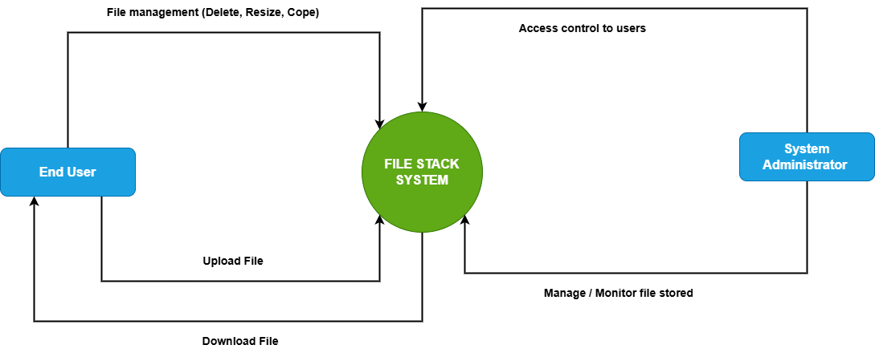
Figure 2.4

The use context diagram illustrates how users interact with the Filestack system. The end user can upload files into the system and download previously uploaded files when needed. The user can also manage files by performing operations such as deleting, resizing, and copying files, allowing efficient control over stored content. The system administrator is responsible for managing access control by granting or restricting user permissions. In addition, the administrator monitors and manages stored files to ensure proper usage, security, and system performance. These interactions enable effective file handling and secure management within the Filestack system.

2.3.1.3. Use Case Diagram for Filestack

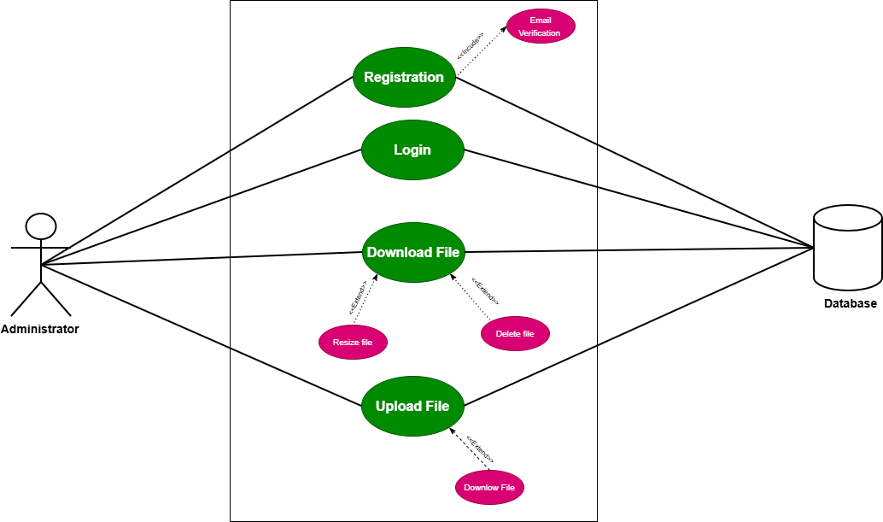
Figure 2.5

The use case diagram illustrates the interaction between the end user and the Filestack system. The end user can register, log in, upload files, and view stored files. During registration, the system performs email verification to ensure the validity of user information. After successful registration, the user can log in to access the system.
Once logged in, the user can upload files, and this process extends to additional actions such as deleting files and resizing files, allowing the user to manage uploaded content effectively. The user can also view files, and this use case extends to downloading files when needed.
All major operations including registration, login, file upload, and file viewing are connected to the system database, where user details and file information are securely stored and managed. This ensures proper data handling, security, and efficient retrieval of information within the system.

2.3.1.4. Sequence Diagram for Filestack

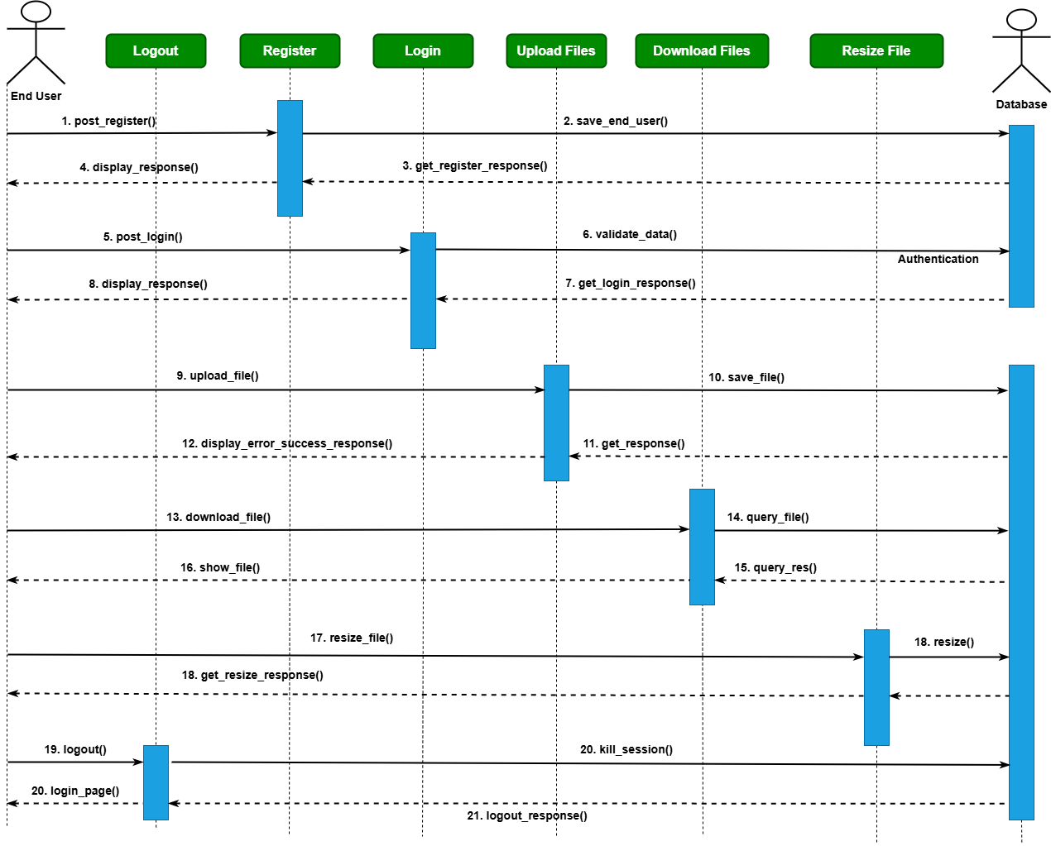
Figure 2.6

The sequence diagram illustrates the step-by-step interaction between the user and the Filestack system. First, the user registers by submitting registration details, which are sent to the database for storage. The system then processes the request and returns a registration response to the user, indicating success or error.
Next, the user logs in, and the system validates the login details by checking the database. After verification, a login response is returned to the user indicating whether authentication was successful.
Once authenticated, the user can upload files, and the system stores the file and related information in the database before returning an upload response to the user. The user can also download files, where the system retrieves the requested file from the database and sends a download response back to the user if the operation is successful.
Additionally, the user can resize files, and the system processes the request before returning a resize response indicating success or failure. Finally, when the user logs out, the system terminates the active session and returns a logout response to confirm that the session has been successfully closed.
This sequence ensures proper communication between the user, system, and database while maintaining secure and efficient file management.

2.3.1.5. Features of the System
Filestack provides a comprehensive file management solution that allows users to upload, store, and download files such as images, videos, and documents. The system supports advanced file processing features, including resizing, cropping, compressing, and converting files into different formats. Users can manage their files by performing operations such as deleting, copying, and transforming them as needed. Filestack also ensures fast file delivery through a global content delivery network (CDN) and provides secure access through authentication and access control mechanisms. Additionally, the system supports multi-source file uploads, enabling users to upload files from local devices, URLs, or third-party cloud services.

2.3.1.6. Development Tools and Development Environment of the System
Filestack provides a developer-friendly environment with APIs and SDKs that support multiple programming languages, including JavaScript, Python, PHP, and Ruby. It offers a web-based file picker and integration tools that simplify implementation in web and mobile applications. The system operates on cloud infrastructure with CDN support, ensuring high performance, scalability, and availability. Filestack is compatible with various web frameworks and mobile platforms, making it flexible for integration into different development environments. Its infrastructure also supports secure file handling, real-time processing, and seamless deployment without requiring complex backend setup.

2.3.2. Review of the Good Features
Filestack offers a powerful and flexible file management solution with an easy-to-use interface for uploading and managing files. It supports advanced file processing features such as resizing, cropping, compressing, and format conversion, which enhances file usability and performance. The system ensures fast and reliable file delivery through a global content delivery network (CDN), improving access speed for users. It also provides secure file handling with authentication and access control mechanisms. Additionally, Filestack is developer-friendly, offering APIs and SDKs that allow seamless integration into web and mobile applications.

2.3.3. Review of the Bad Features
Despite its strengths, Filestack is not specifically designed for academic environments, such as managing examination scripts. The system does not provide built-in workflow management or notification features for lecturers and administrators. It relies on an internet connection for all operations, which may limit accessibility in low-connectivity areas. Furthermore, there is limited control over internal data organization and indexing without additional custom development. The cost of using Filestack may also increase with higher storage usage and advanced features, making it less suitable for low-budget implementations.

2.3.4. Summary of the System Review
Overall, Filestack is a robust and scalable file uploading and management platform that provides efficient file handling, processing, and delivery through cloud infrastructure. It simplifies file integration in modern applications and ensures fast and secure access to files. However, it lacks specialized features required for academic systems, such as structured indexing, workflow automation, and time-based access control. Therefore, while Filestack is suitable for handling file storage and processing, additional development is required to meet the specific needs of an examination script management system.

2.4. Review of System 3: OpenKM Document Management System

2.4.1. Description of the System

2.4.1.1. Overview of the System
OpenKM is an open-source document management system designed to help organizations store, organize, manage, and track digital documents efficiently. It provides a centralized platform where users can upload, access, and manage files such as documents, images, and records. The system supports features like document indexing, search functionality, version control, and workflow automation, which improve document organization and retrieval.
OpenKM is widely used in organizations and institutions to manage large volumes of digital information securely. It includes role-based access control, ensuring that only authorized users can access or modify documents. The system also maintains an audit trail, allowing administrators to track document activities such as uploads, edits, and downloads.
Built using Java and supported by databases such as MySQL and PostgreSQL, OpenKM can be deployed on both cloud and local servers. It provides a web-based interface that allows users to interact with the system easily through a browser. Overall, OpenKM offers a structured and secure approach to document management, making it suitable for organizations that require efficient document handling and control.

2.4.1.2. Context Diagram for OpenKM Document Management System

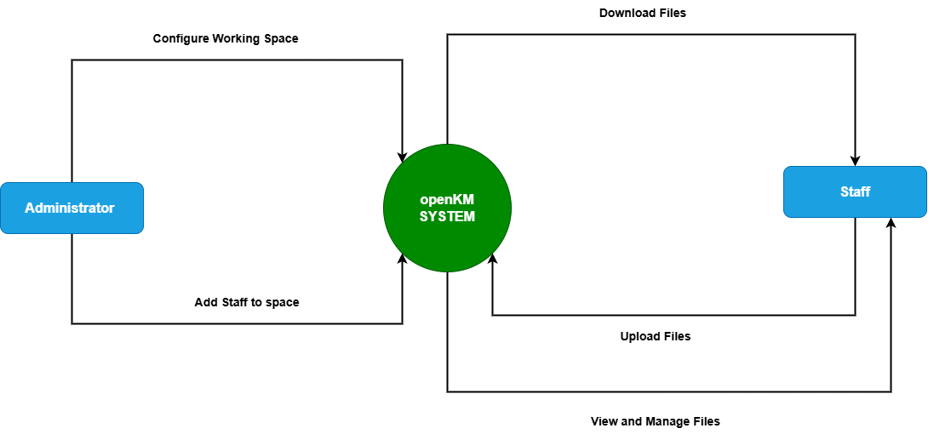
Figure 2.7

The context diagram illustrates the interaction between the OpenKM system and its external users. The administrator is responsible for configuring document spaces and adding users to these spaces, ensuring proper organization and access control. The users or staff interact with the system by uploading documents to the assigned space, downloading documents when needed, and viewing all available files within that space. The OpenKM system acts as the central platform that manages document storage, access, and retrieval, while ensuring that all interactions are controlled and secure.

2.4.1.3. Use Case Diagram for OpenKM Document Management System

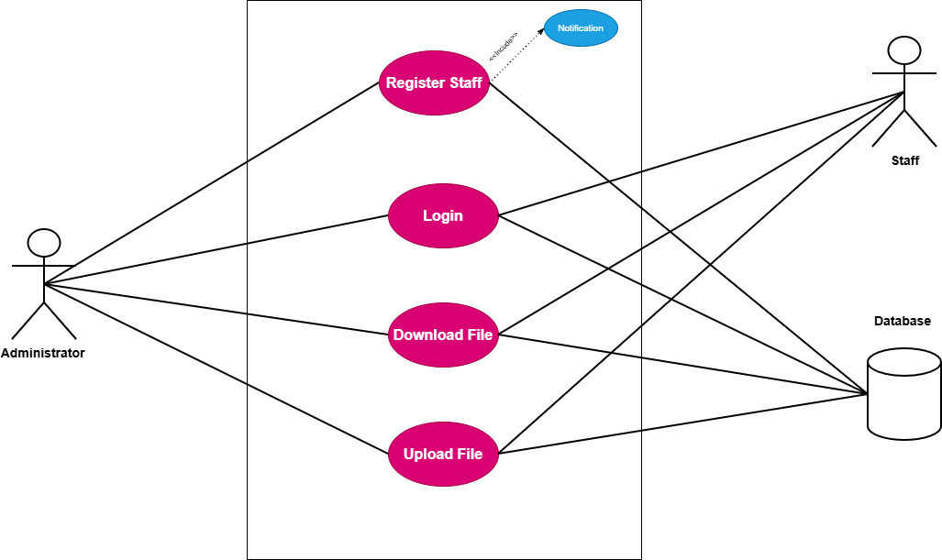
Figure 2.8

The use case diagram illustrates the interactions between the administrator and staff within the OpenKM system. The administrator can register staff members into the system, and this registration process includes sending a notification to the staff. The administrator can also log in, upload documents, and download documents from the system.
The staff receives notifications upon registration and can log in to access the system. Once authenticated, staff members can upload and download documents within their assigned space.
All major operations, including registration, login, file upload, and file download, communicate with the system database, where user information and document data are securely stored and managed. This ensures proper authentication, data integrity, and efficient document handling within the OpenKM system.

2.4.1.4. Sequence Diagram for OpenKM Document Management System

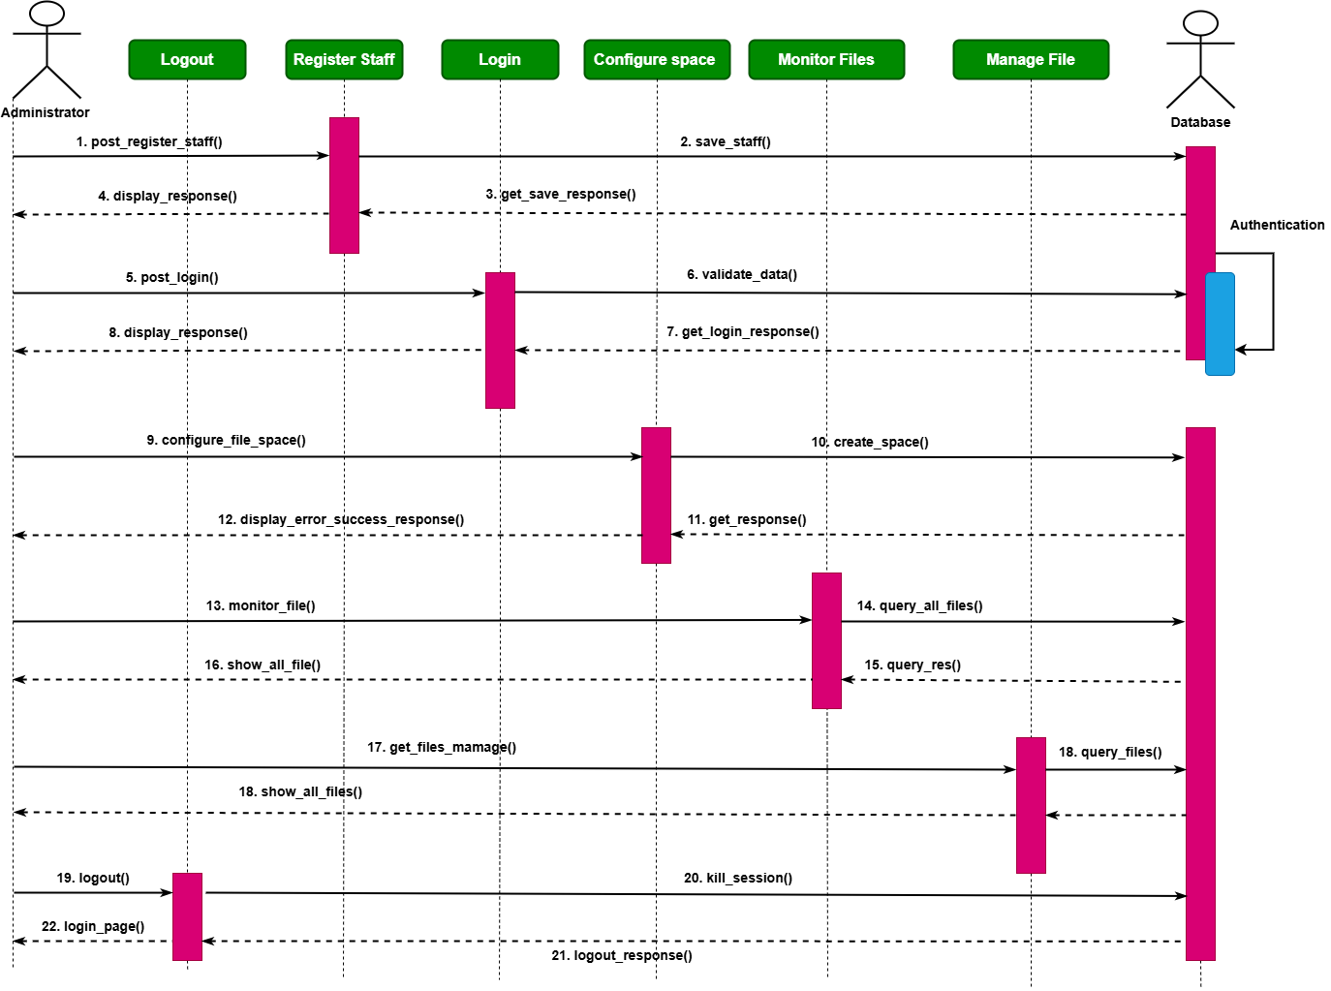
Figure 2.9

The sequence diagram illustrates the interaction between the administrator and the OpenKM system. First, the administrator registers staff, and the registration details are sent to the system and stored in the database. After successful storage, the system returns a registration response to the administrator indicating success or failure.
Next, the administrator logs in by providing login credentials. The system validates the credentials by checking the database, and a login response is returned to confirm whether authentication is successful.
After logging in, the administrator can configure a document space. The system processes the request, creates the space in the database, and returns a confirmation response to the administrator.
The administrator can then upload files into the system, where the files are stored and recorded in the database. The system sends an upload response indicating whether the operation was successful. The administrator can also monitor uploaded files, as well as view and manage files, with the system retrieving the necessary information from the database and returning appropriate responses.
Finally, when the administrator logs out, the system terminates the active session, and a logout response is returned to confirm that the session has been successfully closed.

2.4.1.5. Features of the System
OpenKM provides a comprehensive document management solution that allows users to upload, store, organize, and retrieve digital documents efficiently. The system supports document indexing and metadata tagging, which improves search and retrieval of files. It includes version control to track document changes and maintain history. OpenKM also offers workflow automation, enabling structured document processes within an organization. Additionally, the system provides role-based access control to ensure that only authorized users can access specific documents, along with audit tracking to monitor document activities such as uploads, downloads, and modifications.

2.4.1.6. Development Tools and Development Environment of the System
OpenKM is developed using Java-based technologies and operates on a web-based platform that allows users to access the system through a browser. It uses database management systems such as MySQL and PostgreSQL to store document data and user information. The system can be deployed on both cloud and local server environments, providing flexibility depending on organizational needs. It also supports integration with other enterprise systems through APIs and web services. Its architecture is designed to ensure scalability, security, and efficient document processing within different operating environments.

2.4.2. Review of the Good Features
OpenKM offers strong document organization through features such as indexing and metadata tagging, which make file retrieval efficient and accurate. The system provides advanced search functionality, allowing users to quickly locate documents. Its role-based access control enhances security by restricting access to authorized users only. Workflow automation improves operational efficiency by streamlining document processes. Additionally, the audit trail feature ensures transparency and accountability by tracking all document-related activities within the system.

2.4.3. Review of the Bad Features
Despite its advantages, OpenKM can be complex to set up and configure, especially for users without technical expertise. The system may require significant time and resources for proper implementation and maintenance. Its user interface may not be very beginner-friendly, which can affect usability for new users. Additionally, OpenKM is not specifically tailored for academic environments such as examination script management, and may require customization to meet such specific needs.

2.4.4. Summary of the System Review
Overall, OpenKM is a powerful and structured document management system that provides efficient document storage, organization, and control. It offers strong security, workflow automation, and advanced search capabilities, making it suitable for organizations handling large volumes of documents. However, its complexity and lack of specialization for academic use limit its direct applicability in examination script management systems. Therefore, while OpenKM provides a solid foundation for document management, additional customization is required to meet specific academic requirements.

